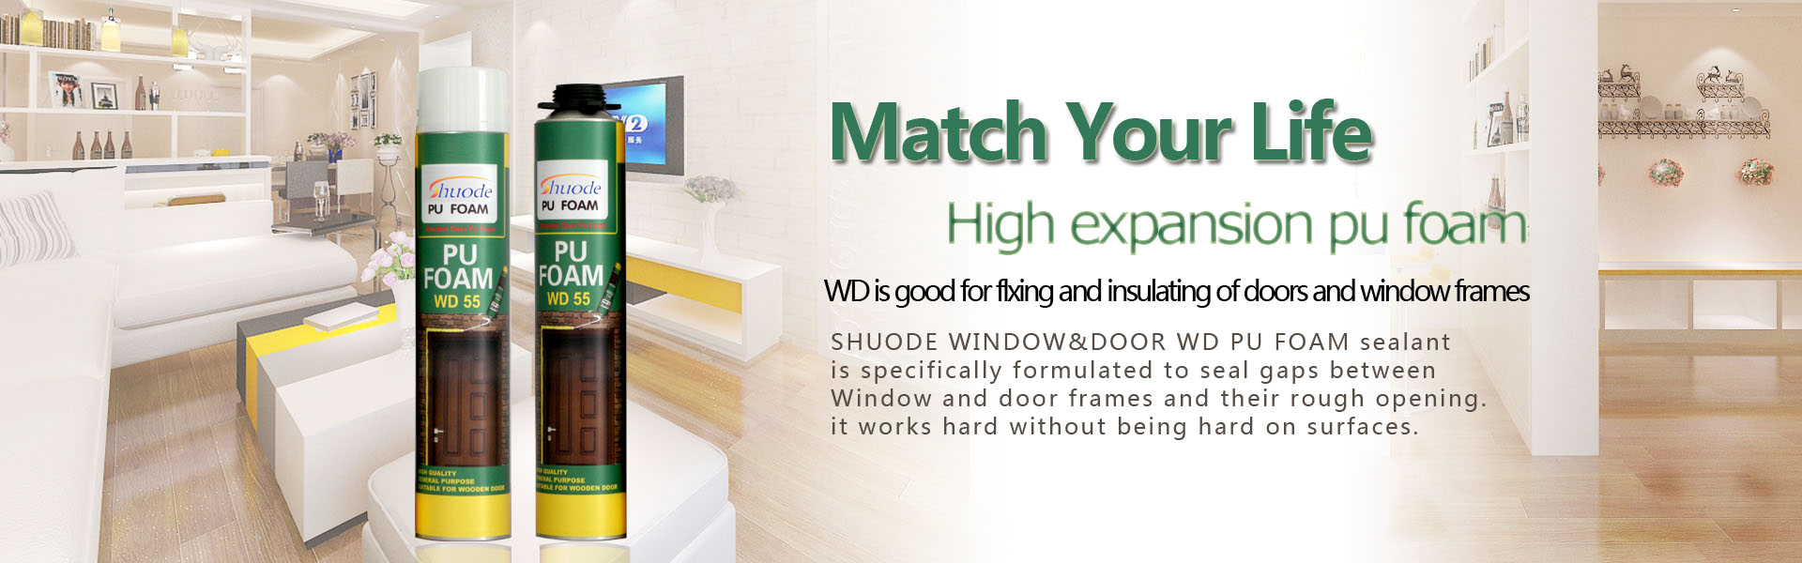
FAQ三：What kind of pu foam is good?
Generally speaking, there are several criteria for judging the quality of pu foam:
1) Adhesion.Some lower grade pu foam in the vertical cracks will flow down, not a good bonding effect.
2) Foam Yield.good pu foam with high expansion,It's very economical（For example,SHUODE’S DR I 750g PU FOAM the foam yield is equivalent to 900 grams.DR II 950g PU FOAM Can spray 32 meters,The price of one bottle and the weight of two bottles.
3) The density of the foam.After the curing of good foaming glue, the foaming hole is uniform and fine, stable and non-powder. The foaming glue foam hole of the lower grade is bigger, the inside after curing is even empty, the bearing capacity is poor, after a pinch with the hand powder.
4) The elastic.The good pu foam solidifies after the elastic good, can bear the very big force action on it,the lower grade product of poor elasticity, after curing with a hand to shrink into a piece of paper.
5) Contractility.All pu foam will be shrink, especially when the temperature is high and the humidity is low.Good pu foam the shrinkage is lesser, do not have influence to the installation of door window basically, the lower grade pu foam the shrinkage is bigger, can damage door window even, especially high-grade wood door, loss is bigger.（SHUODE’S DR I and DRII After a large number of engineering tests, the contraction is basically zero,Especially the wooden door effect is better, and many famous wooden door factories have cooperation. In addition,It is the designated product of Beijing Olympic stadium.

